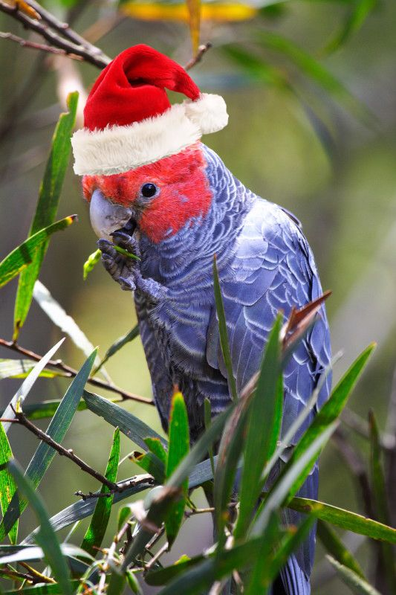 |  | Minton Farm Animal Rescue Centre  - NEWSLETTER Christmas 2016 www.mintonfarm.org, mintonfarm@adam.com.au, https:www.facebook.com/mintonfarmanimalrescue_centre

Centre News
by Bev Langley
What an incredible season it has been. Spring is the great undoing of many an animal rescuer, due to the volume of rescues received and the huge work load. This was the busiest I have seen in 30 years due to the severe weather. Dozens of ringtail possum joeys came to grief because of winds and rain. Baby birds included a tawny frogmouth, boobook owl, white faced heron, silver eye, plovers, silver eye, and even our first ever chough! Some were blown from the trees, some complete with their nests, but many came into care because the whole tree fell over containing their hollows or nests! In addition to the possums, there have been kangaroo and koala joeys, some found in street gutters of flowing water in very poor condition.

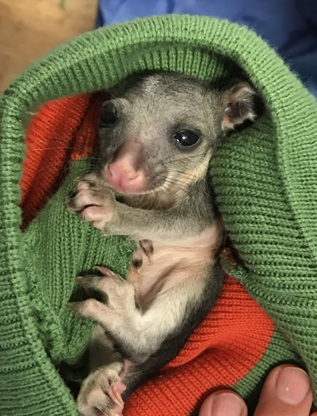

Fortunately, with the help of our wonderful Intensive Care Units, all have survived. With over 10,500 rescues performed onsite, we still see creatures that have never been admitted before, such as a huge Eastern Banjo frog! It is these wonders of things to come that keep us all in awe of our incredible wildlife.

The philosophy of the Rescue Centre is to rescue, rehabilitate and release injured and orphaned wildlife. To this end all of our work and methods concentrate on seeing the animal successfully leave the Centre in a better state than they arrived in. People often say how sad it must be to let them go and I often say what a joy it is to see them fly away back to their families. On the whole this is true, but of course there are exceptions where your head must rule your aching heart. There have been a handful of creatures that caused me to consider the best outcomes of the release. One was a long neck tortoise that lay under the water, gazing into my eyes endlessly, instead of swimming away from me. This year it was a tiny 600 gram koala found at deaths door in a flowing gutter. He thrived with some TLC; growing well, drinking his bottle calmly and contentedly chewing his fresh gum leaves. Buffy has been the most pleasurable rescue of the year and I wish him well as he grows into a fine adult.
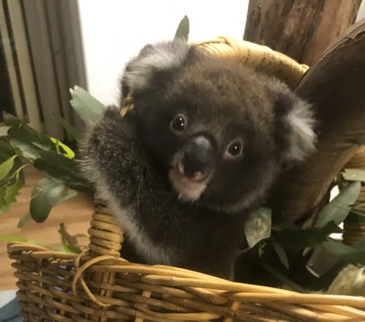

The volunteer program has evolved from being comprised of two 8 year old children 20 odd years ago, to a program offered twice a week to University aged students right through to retirees. Many volunteers have come to the Centre this year from overseas, wishing to learn more about Australian wildlife. Others come for the interaction with a beautiful group of positive, hardworking people, all working to improve the Centre and ultimately, the lives of the unique animals we encounter.

The Volunteer Program runs Tuesday or Thursday 10am to 2pm. To enrol please email mintonfarm@adam.com.au

2016 has also been a hectic fund raising year. We successfully tried selling the wonderful Entertainment Books, as well as the people’s Choice Community Lottery tickets. We have been supported by many other kind people who ran Fund raising Dinners, Charity Art Exhibitions and wildlife painting raffles, for all of which we are deeply grateful. The funds raised have been invested into the Rescue Centre via equipment purchases, medical supplies, and a beautiful new feed room to store seed cleanly and hygienically after 20 years of trying to manage with a leaky, low roofed lean-to! Our garage sale was again a wonderful success, thanks to those who supported it by donating goods or attending. Thank you.

I look forward to the adventures the New Year will bring, and to providing our free community service next year. I am deeply grateful to the myriad of kind people who have assisted the Centre this year. I hope you all have a happy, safe and enriching Christmas.
Merry Christmas. Xx
www.mintonfarm.org

A House full of Ringtails
By Judy Gonda
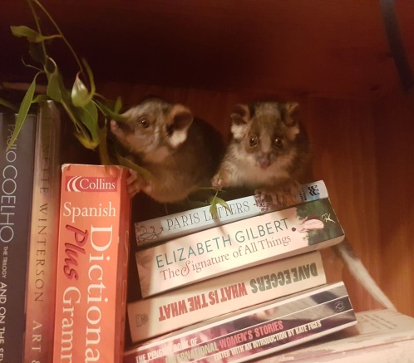When thinking of his childhood in Germany, Ollie Koch remembers always being fascinated by animals. So when he came to Australia almost 2 years ago it was no surprise that he decided that he wanted to get involved in helping our native animals. Consequently in March this year he became a volunteer at Minton Farm. Being very committed to the volunteer role, Ollie was chosen to accompany Bev to the Wildlife Rehabilitation Conference in Melbourne which further stimulated his interest. So, when the centre was overwhelmed with injured and orphaned animals this spring, it was inevitable that he would offer to adopt- specifically, 5 tiny ringtail possums; Nibsy, Samson Sunny, Daisy and Sid. Since then it has been pretty busy in the Koch household. At first the possums needed to be fed 3 times a day. This involved mixing a specific formula into a syringe, wrapping each possum in a beany and hand feeding it. Of course there also had to be a little bit of play time. Unfortunately one of the possums didn’t survive, but the others have thrived and all have progressed to be able to feed themselves. Nibsy and Samson have been weaned from milk and transferred into an outside aviary. Ollie says that “watching them grow and change; seeing the differences between them - their markings and individual characters” and “to be able to be so close to an animal that you rarely get to see” is what he likes best about having the possums. The downside however, is “the time it takes to gather and prepare their food and keep them clean… but it’s all definitely worth it”.
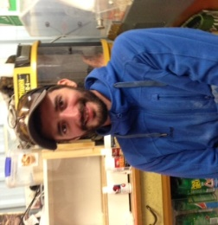

Fundraising
Minton Farm Animal Rescue Centre has rescued just over 10,500 injured and orphaned native animals and birds onsite, to date. This Christmas, L.J Hookers Blackwood, are unable to coordinate the Christmas Food Appeal to assist with the animals that come in over the Christmas season. However, we are pleased to announce that Hillbilly's coffee shop, next to L J Hookers, will be holding a food drive for the animals. There will be a Christmas tree outside the shop where donated food may be left from 8.30
to 4.30pm every day until Dec 23rd. We are deeply grateful to Barbara for her kindness. She is also setting up a "book bit" where books will be sold at the shop, with all proceeds going to Minton Farm. Sanderson's Fodder store on Main Road Coromandel Valley has new owners who are also running a Christmas Appeal for food donations for the Sanctuary. Please consider donating food for the animals for Christmas if you are in Blackwood or Coromandel Valley and support these local businesses at the
same time. Donations of cereals, bird seed, poultry food, dog food, horse and goat pellets, chaff and hay are invaluable and deeply appreciated. If you are unable to donate goods, please consider sponsoring the Centre as Christmas presents to family and friends. $35 sponsorship gives them a Certificate, newsletter and regular updates for one year. Payment may be made online through the www.mintonfarm.org sponsorship page with PayPal; by direct debit to BSB 105 078 Account 056 591 840; or by mail to 455 Cherry Gardens Road, Cherry Gardens, SA, 5157 or sending credit card details to mintonfarm@adam.com.au

Your support ensures the
continuation of our free community service to assist wildlife in need.

Merry Christmas
Bev Langley

